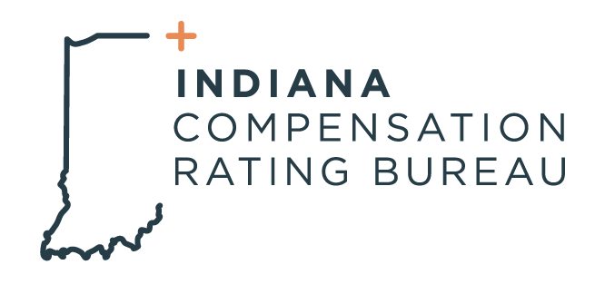

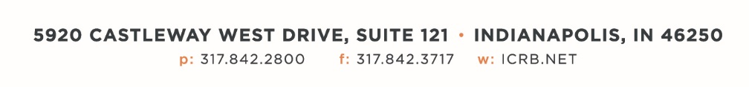

March 12, 2024

ICRB GOVERNING BOARD & ANNUAL MEETING AGENDA

In accordance with ICRB Bylaws Article IX.5, this document provides written
notice of the meeting to all Members and is posted on ICRB’s website.
Date: | Tuesday, March 12, 2024
Time: | 9:00am
Location: | ICRB Board Room (this is a hybrid meeting, so you also have the option of attending via Zoom)

- Welcome and Roll Call
- Anti-Trust Statement
- Approval of previous Governing Board meeting minutes, December 12, 2023
- Updates on Stakeholder meetings and the NCCI Forum
- Trustee/Reinsurance Pool Reports- Dave & Barrett
- AR Limited Other States Coverage Update/Discussion
- Update on proposed Subrogation legislation- NCCI Report
- Audit Status
- Staff and Operational Metrics
- Upcoming Business/Events
- Other Business
- Executive Session

