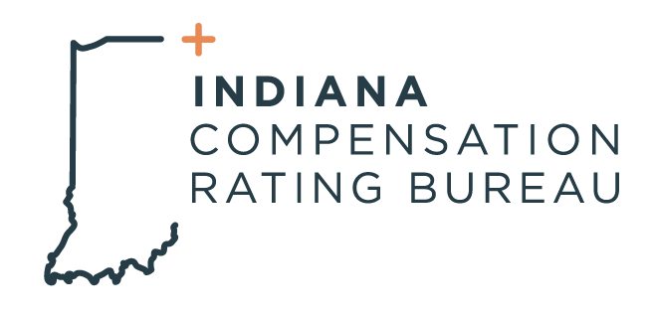

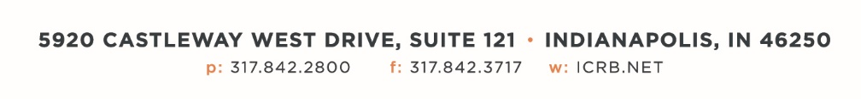

June 18, 2024

**ICRB GOVERNING BOARD & AGENDA**

*In accordance with ICRB Bylaws Article IX.5, this document provides written*

*notice of the meeting to all Members and is posted on ICRB’s website.*

|  |  |
| --- | --- |
| **Date:** | Tuesday, June 18, 2024 |
| **Time:** | 9:00am |
| **Location:** | ICRB Board Room (this is a hybrid meeting, so you also have the option of attending via Zoom) |
|  |  |

1. Welcome and Roll Call
2. Anti-Trust Statement
3. Approval of previous Governing Board meeting minutes, March 12, 2024
4. Governing Board Update
5. Updates on WCIO, PRAC, and AIS
6. NCCI- Docusign/E-signature project
7. Kid’s Chance
8. AR Pool Investment Policy
9. Trustee/Reinsurance Pool Reports- Dave & Barrett
10. AR Limited Other States Coverage Update/Discussion
11. Audit Status
12. Pen Test
13. Staff and Operational Metrics
14. Other Business
15. Executive Session