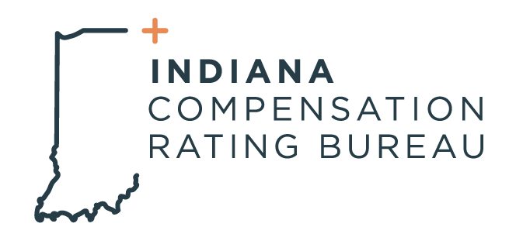

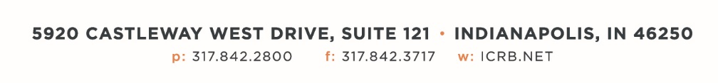

October 1, 2024

**ICRB GOVERNING BOARD & ANNUAL MEETING AGENDA**

*In accordance with ICRB Bylaws Article IX.5, this document provides written*

*notice of the meeting to all Members and is posted on ICRB’s website.*

|  |  |
| --- | --- |
| **Date:** | Tuesday, October 1, 2024 |
| **Time:** | Immediately following Annual Meeting (9:00am) |
| **Location:** | ICRB Board Room (this is a hybrid meeting, so you also have the option of attending via Zoom, link below.  <https://zoom.us/j/99047599302?pwd=S29XRDQ1Sm9JejJlVmxZQkI0SzdFUT09> |
|  |  |

1. Welcome
2. Anti-Trust Statement
3. Approval of previous Governing Board meeting minutes, June 18, 2024
4. Trustee/Reinsurance Pool Report (Dave & Barrett)
5. January 1 2025 Advisory Rate/Loss Cost Filing
6. Reinsurance Pool Audit and SOC Audit
7. ICRB Bylaws- Outside Board Member discussion
8. Operational Metrics- Scott and Jenn
9. 2025 Meeting Dates
10. Other Business
11. Executive Session