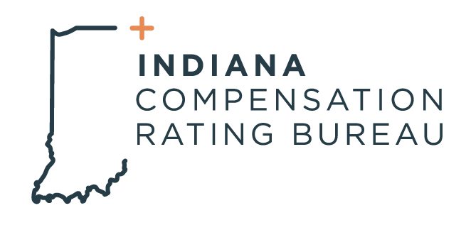

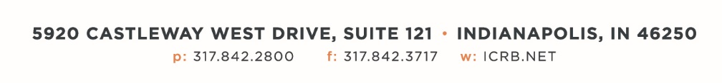

October 1, 2024

**ICRB ANNUAL MEETING AGENDA**

*In accordance with ICRB Bylaws Article IX.5, this document provides written*

*notice of the meeting to all Members and is posted on ICRB’s website.*

|  |  |
| --- | --- |
| **Date:** | Tuesday, October 1, 2024 |
| **Time:** | 9:00am |
| **Location:** | ICRB Board Room or via Zoom (See link below)  <https://zoom.us/j/99047599302?pwd=S29XRDQ1Sm9JejJlVmxZQkI0SzdFUT09> |

1. Welcome and Roll Call
2. Anti-Trust Statement
3. Approval of previous Annual Meeting minutes, September 19, 2023
4. Big I- Steve Duff
5. Business Meeting: Election of 6 Board Members (based on recommendation from Nominating Committee)

Six companies’ terms expire in September 2024. The companies are:

* Accident Fund Insurance Company of America
* American Home Assurance Company (AIG)
* Eastern Alliance Insurance Company
* Indiana Farmers Mutual Insurance Company
* Pennsylvania Manufactures Association Ins Co. (Old Republic)
* Westfield Insurance Company

1. SFM Mutual- New Board Position Proposal
2. Election of Governing Board Chair and Vice Chair
3. Committee Appointments:

**Actuarial Committee:**

AIG, Indiana Farmers, Liberty Mutual

**Audit Committee:**

Westfield, Travelers, Accident Fund

**Contract Committee:**

AIG, PMA (Old Republic), Westfield, Eastern Alliance

**Litigation Committee**:

Eastern Alliance, FCCI, AIG, Travelers

**Nominating Committee:**

Travelers, AIG, Old Republic

**Finance Committee:**

AIG, Travelers, Indiana Farmers, Old Republic

**Dispute Resolution Committee:**

Indiana Farmers, Eastern Alliance, Liberty Mutual, Indiana Manufacturer’s Association

1. Other Business
2. Adjourn